Mathe Mmabotse Thandi

ST10477671

  - PROG6212 POE

Section A
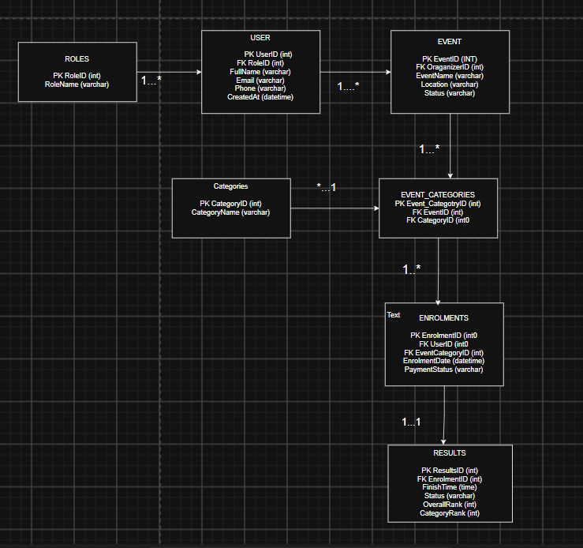

Part A - Entity Relationship Diagram

The Entity Relationship Diagram (ERD) illustrates the database architecture of the RaceDay application and depicts the interconnections between the varied entities found in the application. The entities in the system are ROLES, USER, EVENT, CATEGORIES, EVENT_CATEGORIES, ENROLMENTS and RESULTS. Primary keys are ascribed to every entity, which is used for identifying every record in the database and foreign keys are used to create links between the different entities.

There exists a one-to-many relationship between ROLES entity and the USER entity such that one role can be awarded to several users, and every user has only one role. The USER entity here exhibits one-to-many connections with EVENT entity, with one user being able to arrange many events but every event being arranged by only one user.
Both EVENT and CATEGORIES entities follow a many-to-many relation between them, which is mediated by the EVENT_CATEGORIES entity. It means that one event can assume several categories, and one category might be taken by many events. To account for that, the EVENT_CATEGORIES entity carries with itself the foreign keys EventID and CategoryID.
EVENT_CATEGORIES is related to ENROLMENTS in a one-to-many relationship because every event category can have several participants who will enrol in it. Similarly, USER entity also has one-to-many relationship with ENROLMENTS. Each user can enrol in various event categories, but each enrolment is related to only one user.
Moreover, ENROLMENTS exhibits a one-to-one relationship with RESULTS in that each enrolment can possess only one result, while one result belongs to one enrolment. The RESULTS entity provides information about the performance of the participants in the race, i.e. finishing time, status, overall and category ranks.
Keys used in ERD are primary and foreign keys which are responsible for ensuring the integrity of the information and building relationships among the entities. The conclusion can be that the structure of the database also helps to eliminate duplication of the information.

Section B involves the API Endpoint Plan.

HTT P METHOD | ROUTE | DESCRIPTION | ROLE REQUIRED | REQUEST BODY | EXPECTED RESPONSE
POST | /api /auth/register | Registers a new user account in the RaceDay system. | None | {name, email, password, role} | 201 Created – User registered successfully.  400 Bad Request – Invalid or missing data.
POST | /api/auth/login | Authenticates a user and provides an access token/ session | None | {email, password} | 200 OK -Login successful with user details/token.  401 Unauthorized – Invalid email password.
GET | /api/user/profile | Retrieves the profile information of the currently logged-in user. | Any logged in | None | 200 OK – User profile returned.401 Unauthorized – User is not logged in.
PUT | /api/auth/profile | Updates the Profile information of the currently logged-in user. | Any logged in | {name, email, password} | 200 OK – Profile updated successfully. 400 Bad Request – Invalid data. 401 Unauthorized – Not logged in. 409 Conflict – Email already in use.
GET | /api/ events | Returns a list of available RaceDay | None | None
GET | /api/events/{id} | Returns detailed information about specific event. | None | None | 200 OK – Event details returned. 404 Not Found – Event does not exist.
POST | /api/ events | Creates a new RaceDay event. | Admin | {name, description, date, location, capacity} | 201 Created – Event created successfully. 400 Bad Request – Invalid data. 401  Unauthorized – Not logged In.
PUT | /api/events/{id} | Updated the details of an existing event. | Admin | {name, description, date, location, capacity} | 200 OK – Event updated successfully.404 Not Found – Event does not exist. 403 Forbidden – Insufficient permissions.
DELETE | /api/events/id} | Deletes an existing event from the system. | Admin | None | 204 No Content – Event deleted successfully. 404 Not Found – Event does not exist.
GET | /api/categories | Returns all race categories available in RaceDay. | Admin | None | 200 OK – List of categories returned.
GET | /api/categories/ {id} | Returns details of a specific race category. | None | None | 200 OK – Category returned.
POST | /api/categories | Creates a new race category. | Admin | { name, description } | 201 Created – Category created. 400 Bad Request – Invalid data. 403 Forbidden – Admin access required.
PUT | /api/categories/ {id} | Updates an existing race category. | Admin | { name, description } | 200 OK – Category updated. 404 Not Found – Category does not exist.
DELETE | /api/categories/ {id} | Deletes an existing race category. | Admin | None | 204 No Content – Category deleted. 404 Not Found – Category does not exist. 409 Conflict – Category is being used by an event.
GET | /api/events/{eventId}/categories | Retrieves all categories associated with a particular event. | None | None | 200 OK – List of event categories returned. 404 Not Found – Event does not exist.
POST | /api/events/{eventId}/categories/{categoryId} | Associates a race category with an event, implementing the event-category relationship. | Admin | None | 201 Created – Category successfully linked to event. 404 Not Found – Event or category does not exist. 409 Conflict – Relationship already exists
DELETE | /api/events/{eventide}/categoriess/{categoryId} | Removes a category from an event. | Admin | None | 204 No Content – Category removed from event. 404 Not Found – Relationship does not exist
GET | /api/enrolments | Returns the enrolments belonging to the logged-in user. | Any logged in | None | 200 OK – User’s enrolments returned. 401 Unauthorized – User is not logged in
GET | /api/events/{eventId}/enrolments | Returns all participants enrolled in a particular event. | Admin | None | 200 OK – Enrolment list returned. 404 Not Found – Event does not exist. 403 Forbidden – Admin access required.
POST | /api/events/{eventId}/enrolments | Enrols the logged-in user in a selected RaceDay event | Any logged in | { categoryId} | 201 Created – Enrolment created. 404 Not Found – Event/category does not exist. 409 Conflict – User is already enrolled or event is full.
GET | /api/enrolments/{id} | Retrieves details of a specific enrolment. | Any logged in | None | 200 OK – Enrolment details returned. 404 Not Found – Enrolment does not exist. 403 Forbidden – User does not own the enrolment.
DELETE | /api/enrolments/{id} | Cancels an existing event enrolment. | Any logged in | None | 204 No Content – Enrolment cancelled. 404 Not Found – Enrolment does not exist. 403 Forbidden – User does not own the enrolment.
GET | /api/events/{eventId}/results | Returns the results for participants in a specific event. | None | None | 200 OK – Event results returned.
GET | /api/results/{id} | Retrieves a specific participant’s result. | None | None | 200 OK – Result returned. 404 Not Found – Result does not exist.
POST | /api/events/{eventId}/results | Records a participant’s result after an event has taken place. | Admin | { enrolmentId, position, finishTime } | 201 Created – Result recorded. 400 Bad Request – Invalid result data.
PUT | /api/results/{id} | Correct or updates an existing participant result. | Admin | {Position, finishTime} | 200 OK – Result updated. 404 Not Found – Results does not exist.403 Forbidden – Admin access required.
DELETE | /api/results/id} | Removes an incorrect result from the system | Admin | None | 204 No Content – Result selected. 404 Not Found – Results does not exist.

The endpoint structure
The endpoint plan can therefore be grouped as follows:
> Authentication: /api/auth/register, /api/ auth/login
> User Profile: /api/users/profile
> Events: /api/events
> Categories: /api/categories
> Event Categories: /api/events/{eventId}/ categories/...
> Event Enrolments: /api/enrolments and / api/events/{eventId}/enrolments
> Results: /api/results and /api/events/ {eventId}/results
This structure keeps the API consistent with the RaceDay ERD: Users enrol in Events, Events can have multiple Categories through the event-category relationship, and Results are associated with participants/enrolments.

